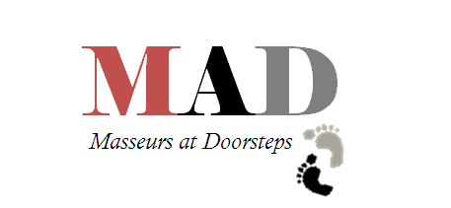

How to reach us??

Swati Dube +91 9560554451

(swati@getmad.in)

Nidhi Goyal +91 9717033032

(nidhi@getmad.in)

How much we charge??

INR 500 per therapy!*

Corporate deals also available

How we do it??

We will come to your office do a small set up in some free space and give your employees a 20 minutes treatment for feet/hands/neck & shoulders without disturbing the office environment and give them a feel of spa @ workplace.

Who we are??

A super cool team of people who are trained and are coming to your doorsteps to help you De-stress!

What we do??

In one word

STRESSBUSTERS!